The Very Busy Spider
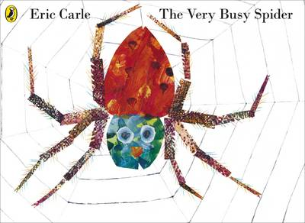

This week’s activities are based on the story ‘The Very Busy Spider’. The plan format is very similar to last week I hope this makes it easy to follow. Below I have included a suggested daily timetable which shows how the varied activities can be stretched throughout the day with big gaps for play time. We love to see your fantastic work so please sent lots of pictures through dojo. Please don’t hesitate to contact us if you would like extra resources or have any questions. Thank you
9/9.30 | Exercise/ Yoga
10.00 | RWI phonics on YouTube (Set 1 at 9.30, Set 2 at 10.00)
11.30 | Literacy
1.00 | Maths
2.30 | The World/ Creative
4.00 | Reading book (ebook)
7.30/8.00 | Bed Time Story

Subject | Monday | Tuesday | Wednesday | Thursday | Friday
Literacy | Look at the picture of the book’s front cover – provided below.  Adult questions to ask: can you find the title? What do you think the story will be about? What do you know about spiders? What is different about this spider? | Read the story or watch the story on Youtube – link given below.  Adult questions throughout the story:  Where do you think the spider landed? Why do the animals ask the spider questions? What do you think the next animal will ask? Why doesn’t spider answer? | Re-read or watch the book again. Can you join in with some parts of the story? Activity: draw pictures of the animals and write what the like to do e.g. The goat likes to jump. The pig likes to roll etc | Can you order the story? Activity: Cut out and stick the sheet provided or draw the sequence of events in the story. | Activity options:  -Write your own retelling of the story.  -Draw and write about your favourite part of the story.  -make a story map
Mathematics | Halving  Using a food item tell your child you want to share it with them but you’re unsure how to. How many do I have? How can we both eat it? We can cut it in half, how can we make it fair? Chop the food in half. Are they the same? Put the food back together to show whole, take apart to show half. | Halving  Activity: Finding half of a shape by folding, cutting or drawing a line down the middle. Remember both sides need to be the same. | Halving  Using objects around the house. Count your objects. Share objects with one other person one for me, one for you. How many do you have each? Is it fair? Is the number the same? Share pencils, toys, books, counters | Halving  Have a teddy bear’s picnic with 2 bears and 2 plates. Share an even number of food items (you can use objects as imaginary food) fairly between the 2 bears. Do they have the same? What would happen if there were 3 bears? | RMEasimaths  Please access RMEasimaths, it is set to your child’s ability starting at a simple level and progressing through the maths curriculum at a suitable pace.
Knowledge of the World/  Creative | Research Spiders  Research questions below | Music  Use instruments (make your own instruments) to play along to the nursery rhyme ‘incy wincy spider’ | Creative  -Draw the other half of the spider (below)  -Make playdough spiders  -make spiders | Outdoors  Can you find any spiders in your garden? Where might they be hiding? Could you make a home for them and other creatures? Bug hotel below  Make a spider’s web with sticks | Baking  Can you make buns or biscuits for sharing?  Cut lunch foods in half  Decorate half of a biscuit

Links and Resources
‘The Very Busy Spider’- https://www.youtube.com/watch?v=TfL0g-XRxnA
Make your own shakers https://www.letsplaykidsmusic.com/homemade-musical-instruments-shakers-maracas/
Daily phonics lesson- https://www.youtube.com/channel/UCo7fbLgY2oA_cFCIg9GdxtQ
Free ebooks (log in as a parent)- https://home.oxfordowl.co.uk/reading/reading-age-4-5-reception/
Other stories
Aaaargh Spider- https://www.youtube.com/watch?v=7OCamTmAoFc
Walter’s Wonderful Web- https://www.youtube.com/watch?v=AQ9MK2zqvOw
Family Films-
Charlotte’s Webb, Spider-Man

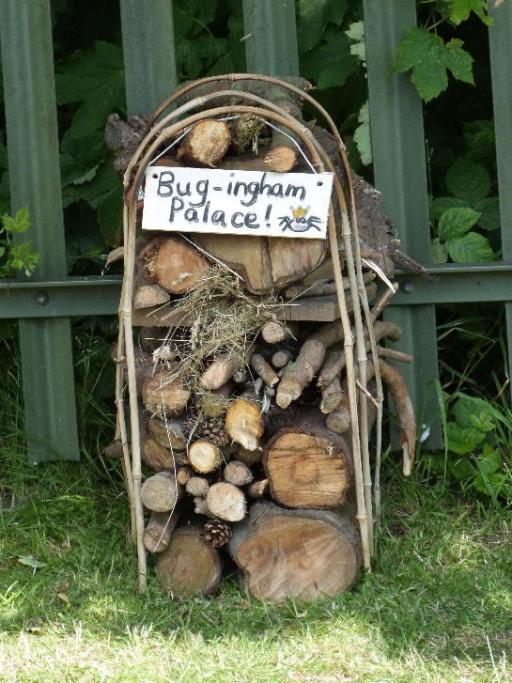
Bug hotel Spiders web with sticks

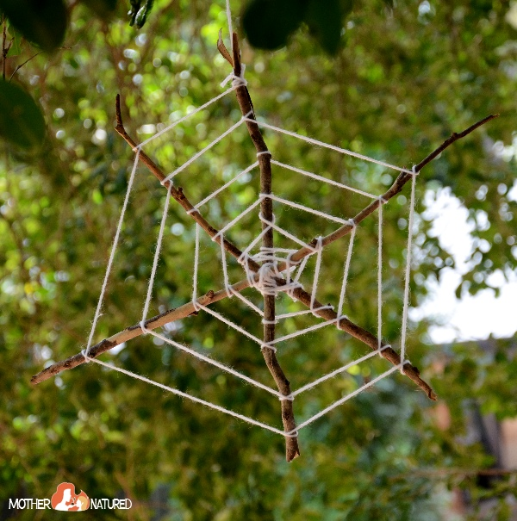
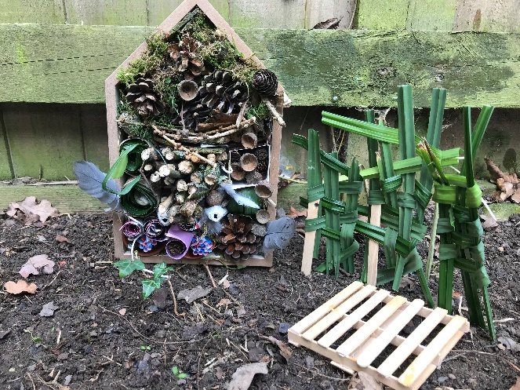

Front Cover

Story map
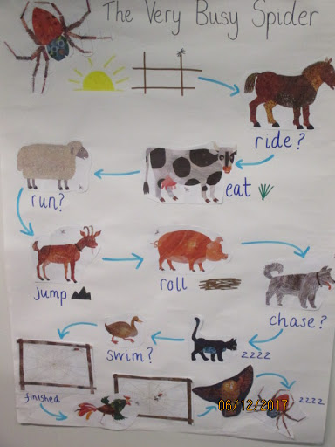

Cut and stick sequencing
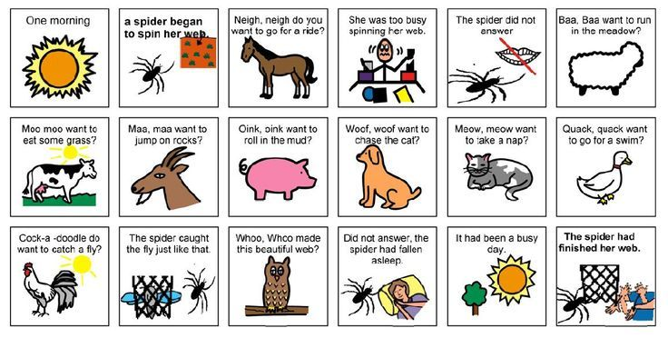

Draw the other half of the spider

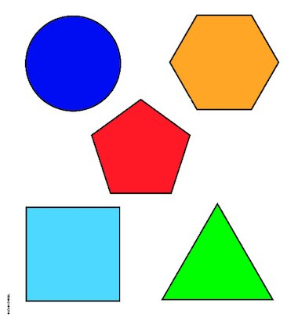
Find half of the shape

Spider research questions
- How big is the smallest spider to be discovered?
……………………………………………………………………………………………………………………………………………….……………………………………………
- Where does that spider come from?
……………………………………………………………………………………………………………………………………………………………………………………………..
- How many eyes does a spider have?
………………………………………………………………………………………………………………………………………………………………………………………………
- What kind of creature is a spider?
………………………………………………………………………………………………………………………………………………………………………………………………
- Which other creatures are arachnids?
………………………………………………………………………………………………………………………………………………………………………………………………
- What is the only continent where there are no spiders?
………………………………………………………………………………………………………………………………………………………………………………………………
- What kind of spider is Charlotte in Charlotte’s web?
………………………………………………………………………………………………………………………………………………………………………………………………
- What kind of spider bit Spider-Man?
………………………………………………………………………………………………………………………………………………………………………………………………

